Ruby on Rails – Udemy notes
Routes – You can make links to pages inside the routes.rb file
root "pages#home"
get '/about', to: 'pages#about'
get '/help', to: 'pages#help'
Views – Layouts – application.html.erb
This is a “wrapper file' – all the view get served through this page. It has all the HTML setup defaults. Any site – wide changes can be made in this page – anything you want to appear or be used - Navbars, headers, footers, etc - on every page in the website.

Models – help us interact with the database = associations, scopes, validations, etc.

Controllers – add methods(actions) and create instance variables

Naming conventions -
Controllers – plural, snake case - ex. ==> todos_controller.rb
Tables – plural – snake case
Models – singular with .rb extension – has class definition – CamelCase

Practice
rails generate migration create_todos
Will create a folder under db with the timestamp and the migration name specified
- Set up the table using t. and field specs
def up
create_table :todos do |t|
t.string :name
t.text :description
end
end
- run the migrations
rails db:migrate
- create a model for the table just created and defined
class Todo < ApplicationRecord
end
  - use rails console to view the database and tables. In the console, create a todo record

To work with a new object, we need to create a route – using resourceful routing, a controller and a view

To create resourceful routes, enter resources :objectName(photos in the sample below) and ROR will create all the GET, POST, PATCH, PUT and DELETE routing helpers
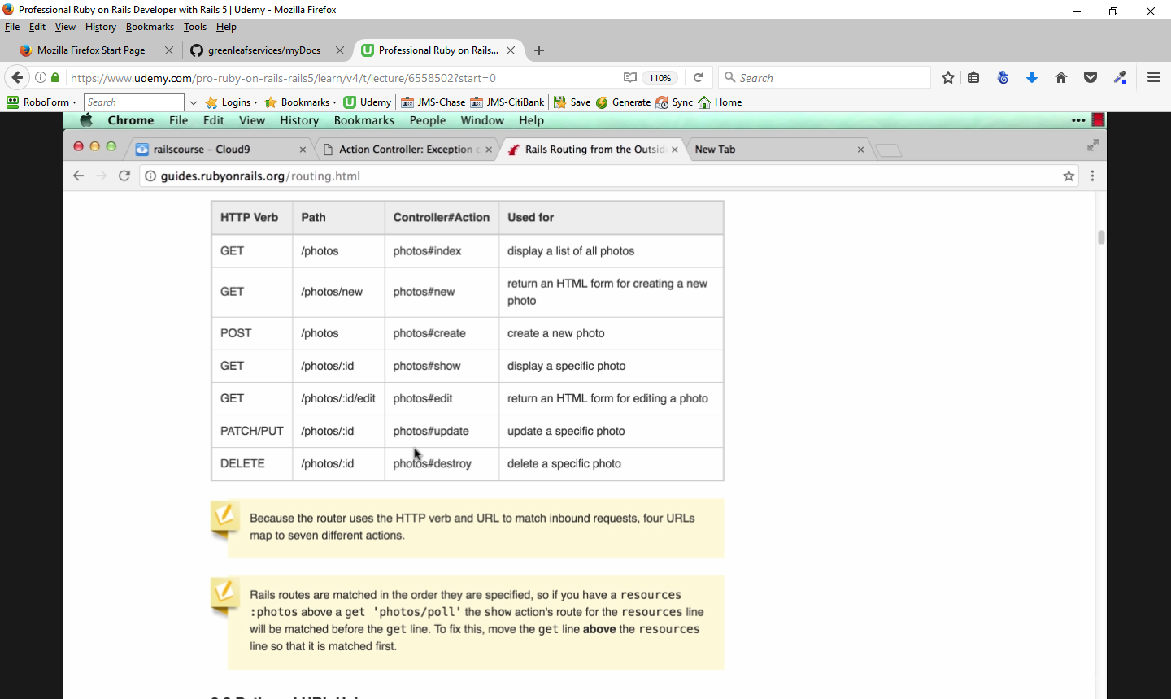
To create an instance, go to the controller for the object and enter
def new
@todo = Todo.new
end
To create a from for an object, use the form_for helper
<%= form_for @todo do |f| %>
<% end %>

Recipe Project

Go to the folder under which you want to store the application
rails new myrecipes
This will build the new app

Then run the rails server:
Test out that you get the rails main welcome page from the browser, then shut down the server
Initiate a git repo:
git init
Then make a commit:
git add -A
git commit -m "Initial commit"
Create a new repository in your github account, then follow the steps (two lines) to move existing app to your github repo
Then test it out and ensure your app is pointing to the right repo by typing in:
git remote -v
Reload the github page and ensure your latest commit/project is showing up

Setting up a testing framework
Install Bootstrap and start homepage - Text lecture
Section 3, Lecture 43

Create an integration test for the pages:
rails generate integration_test pages
This will create a controller under the test folder – pages_test.rb

Then within the class PagesTest, type in the two tests:
test "should get home" do
get pages_home_url
assert_response :success
end

test "should get root" do
get root_url
assert_response :success
end

run your test suite
rails test ==> this will fail because it cannot find the url specified

Add the two routes to the config/routes.rb file:
root "pages#home"
get 'pages/home', to: 'pages#home'

Create the file pages_controller.rb under app/controllers folder and add the home action

class PagesController < ApplicationController
def home
end
end

Add a view for home ==> create a folder named pages under app/views folder then within the pages folder create a file called home.html.erb
<h1>Welcome to MyRecipes App</h1>

Run the tests again ==> if all is OK you'll see the following:
Run options: --seed 46817
# Running:
.. ==> the two dots are for the two runs
Finished in 0.920786s, 2.1721 runs/s, 2.1721 assertions/s.
2 runs, 2 assertions, 0 failures, 0 errors, 0 skips
Now you can check it out on the rails server

Check out getbootstrap.com for homepage ideas, then build a mockup of your homepage

Add the bootstrap sass gem to your gemfile under your rails gem:
gem 'bootstrap-sass', '~> 3.3.6'

Install the gem in the app:
bundle install --without production

Then add the following line to your app/assets/javascripts/application.js file under the line that says //= require jquery_ujs:
//= require bootstrap-sprockets

Create a new file under app/assets/stylesheets folder called custom.css.scss:

@import "bootstrap-sprockets";
@import "bootstrap";

Stop and restart the server – you have to do this anytime you make changes to the gemfile

Database Setup
Ruby – ActiveRecord – abstraction layer – translates Ruby code to SQL
ORM – Object Relational Mapper
Models – creates interface for each database table
Naming convention – database table is plural, model is singular – i.e. -users/user
Creating the model creates the “Getters” and “Setters”
When you set associations, the one that belongs to the other will inherit the “Getters” and “Setters” ability – these are called Virtual Attributes

Steps to produce models and tables
rails generate model tablename(singular) ==> this will create the model and the migration
In models – set up associations – belongs to or has-many as appropriate
In migrations –
Change the def change to def up and add
def down
drop_table :<tablename>
end
This will help in the migration process if there is any need to recreate the table
Then define the columns for each table – setting the column name and type
If the table belongs to another table, set the index for the other table by adding the line
add_index("table you are migrating", "<table that owns this table>_id") #index to foreign table - table name_ID

Then run rails db:migrate to create the tables in the database.

If you make a mistake in the table definition and already ran the migrations,
- You can create a “correcting” migration – i.e. - rails generate migration fix_<table-name> and put the command in that migration.
To change a column name
rename_column :<tablename>, :<columnname>, :<new columnname>
To change a coulmn type
change_column :<tablename>, :<columnname>, :<new type – text, text area, etc>
Running the command rails db:migrate will cause that migration to run and fix the table as requested
- Or, if you haven't done much work in the db, run
rails db:migrate VERSION=0
then fix the migration file and run
db:migrate

Steps to produce controllers
rails generate controller <name-plural> <optional views desired>

Test Driven Development
You can test the associations by creating tests and models use rails test
All the testing will occur in the test database – no actual records will be written during the testing

Setting up the application – continued
Create the controllers for each of the objects in the project
rails generate controller <object> <views>
This will create the controller and the .html.erb files for the views specified for each of the objects. It will also create simple routing in the routes.db table.
In the routes.rb file, delete or comment out the simple match routes (i.e. get ',object>/index') and then create resourceful routes
enter the lines
resources :<objectname> do
member do
get :delete #should be added ,not part of default resources
end
end
This will create the resourceful routes for all the GET, POST, PATCH,PUT and DELETE actions needed for rails to automatically integrate with the database.

Integration Testing – verifies that the pages will show when called – questionable value

rails generate integration_test recipes

test "should get recipes index" do
get recipes_url
assert_response :success
end
This tests simple match routes, not the resourceful routing

Application_helper.rb
This is a place where you put the methods you are going to use in the views. These will be available to your views
Creating a helper to get your gravatar

def gravatar_for(user, options = { size: 80 })
gravatar_id = Digest::MD5::hexdigest(user.email.downcase)
size = options[:size]
gravatar_url = "https://secure.gravatar.com/avatar/#{gravatar_id}?s=#{size}"
image_tag(gravatar_url, alt: user.chefname,
class: "img-circle")
end

To access the gravatar, inset the code bleow in the appropriate area:
<%= link_to gravatar_for(@recipe.chef), recipes_path %>

